Adding Forms in Advanced Mobile Web Application Development

Austin Vanraden

Rasmussen College

Author Note

This project is being submitted on June 6h, 2019, for Darice Corey’s CIS4655C Advanced Mobile Web Application Development course.

Mobile Web Application

In this document, we will go over the changes I have made with this application for this module. Somethings that will be mentioned is updates to code formatting, as well as the formatting of the webpage. Multiple styles of forms will be incorporated into this application.

**Site and Code Links**

URL: <http://sotd.us/austinvanraden/CIS4655C-WebDev/Course%20Project%20Page/ProjectSignUp.html>

GitHub: <https://github.com/AustinVanStroodleBerry/CIS4655C-WebDev/blob/master/Course%20Project%20Webpage/ProjectSignUp.html>

**Sign-Up Page**

All of the changes for these forms were put into the Sign-up Page. The reason for this is because it is the only page out of the pages I currently have that would make sense to have these forms. First, I added all of the required types of forms. A formatting mistake was correcting in the first row across all pages for the nav bar spans across the entire page. The jumbotron banner was incorporated in all of the pages instead of the just home page. Removed some empty <divs> and unused styles since I have now gotten a firm grasp of what everything is doing.

**Sign-Up Page (Desktop View)**

The webpage is incredibly boring to look at. I mostly copy/pasted the code from the example as it had all of the types written for me. Made some adjustments to the required fields, text, selections, and formatting of the form (class=”container was added so there was some padding from the edges).

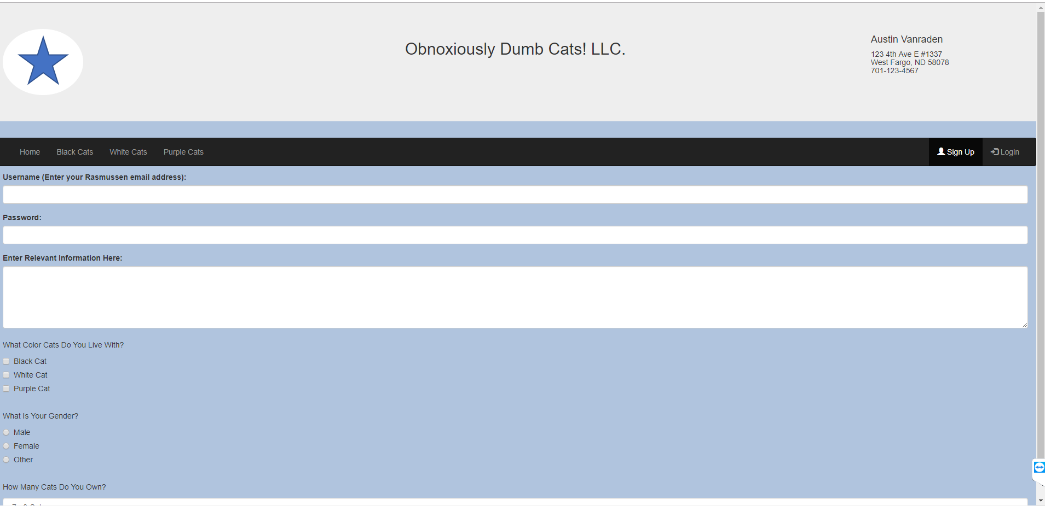

**Sign-Up Page (Mobile View)**

